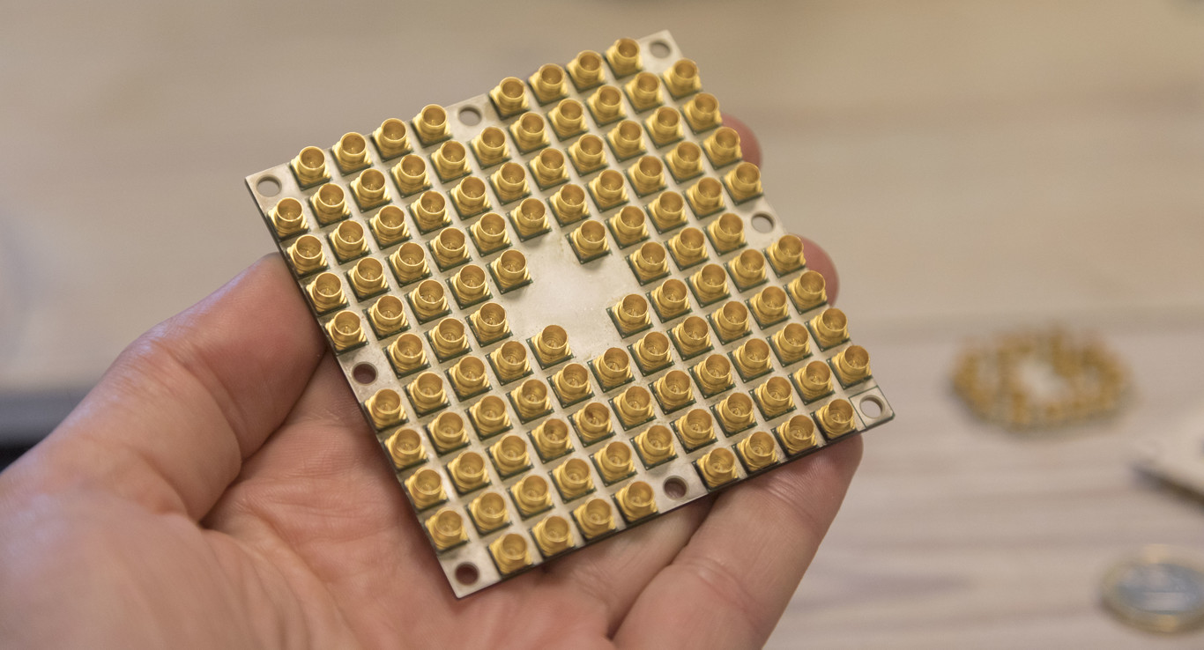

***QUANTUM COMPUTING***

***Contents:***

1. Introduction 3

2. What is Quantum Computer? 4

3. What is a Qbit? 5

4. Quantum Computing VS Classical Computing 7

5. Problems of Quantum Computing 8

6. Possibility of investigation 9

7. Deadlines 11

8. Practical applications 12

9. Applications in the real world 13

10. Lastest news 2019 13

11. Conclusion 15

12. Bibliography (web-links) 16

# ***Introduction***

In the last 5 decades, the processors have become increasingly faster and smaller, but the limits of technology are close to their margin. If the industry wants to continue building even more powerful computers, something has to change.

It is all about fascinating technological promises. Chips made of light, computers that solve problems 3600 times faster than those of traditional machines, artificial intelligence that learns at the speed of a god, computers that work at -260 degrees. All that will be, or would be, a matter for Quantum Computing, which is developing slowly three decades ago.

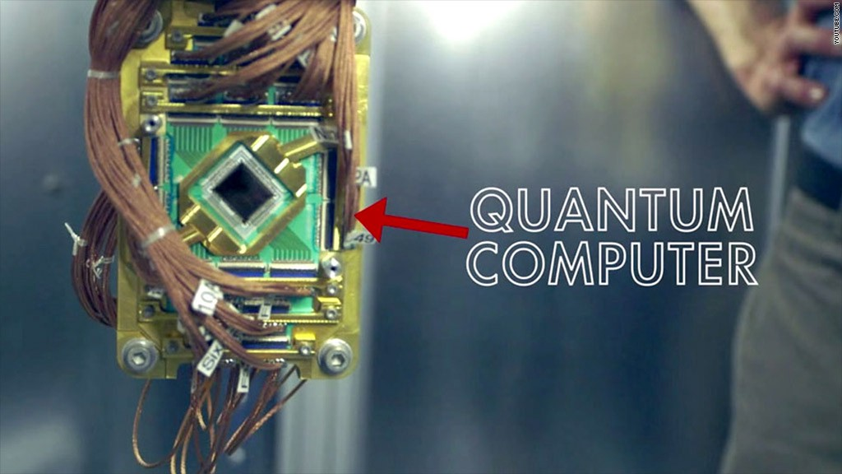

It is not easy to precisely locate in time the exact moment in which Quantum Computing began to make noise beyond the academic and research fields. Perhaps the most reasonable is to accept that this discipline began to be known by the general public about three decades ago, a period during which the classical computes have experienced a very remarkable development.

Although there are scientists who defend with vehemence that the Quantum Computing to which we aspire is impossible, like Gil Kalai, an Israeli mathematician who teaches at Yale University, and the truth is that he has advanced a lot during the last years.

From the outside it may seem like an “eternal promise”, but the advances we are witnessing, such as the construction of the first 50 Qbits functional prototype IBM is working on, invite us to be reasonably optimistic.

The challenges facing mathematicians, physicist and engineers are almost titanic, but this makes this discipline even more exciting. Let’s start our trip.

# ***What is Quantum Computer?***

In recent years, some large technology companies such as IBM, Microsoft, Intel or Google are working in relative silence on something that sounds very good: Quantum Computing.

The main problem with this, at least for us, is that it is difficult to know what exactly it is and what it can be useful for.

There are some questions that can be easily solved. For example, Quantum Computing is not going to be useful at the moment so that you have more FPS on your graphics card. Nor will it be as easy as changing your computer’s CPU by a “Quantum CPU” to make it hyper-fast. Quantum Computing is fundamentally different from the computation to which we are accustomed.

For different scientists, Quatum Computing will be the future of computers, although currently only large companies have been able to acquire or develop one.

A few years ago we learned that Google and NASA acquired a Quantum Computer in their quest to achieve the highest speed of problem resolution and analyse data in a more accurate way.

Different scientists describe Quantum Computing as a baby in diapers that will be the future of computers, although currently only the large companies already mentioned have Access to them.

After this brief introduction, let’s define what a Quantum Computer is. Theoretically it is a computer that uses Qbits to perform operations instead of the traditional bits of classical computers, which allows you to solve problems much faster, which would take an ordinary computer too long or even, it could be unable to solve.

The Quantum Computer that Google and NASA have is the famous D-WAVE 2. They acquired it in 2013 and both entities have collaborated in its development. This computer allows them to carry out research and development work much more quickly, especially in the artificial intelligence jobs they have been developing, especially Google.

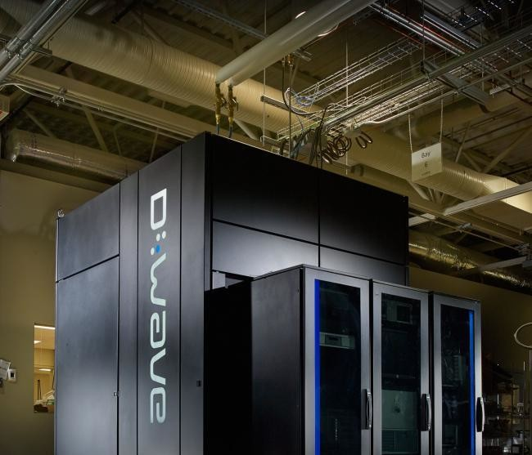

# ***What is a Qbit?***

In the early twentieth century, Planck and Einstein propose that light is not a continuous wave (like the waves of a pond) but is divided into small packages or quanta. This apparently simple idea served to solve a problema called the “ultraviolet catastrophe”. But over the years other physicists developed it and reached surprising conclusions about the matter, of which we will be interested in two: the superposition of states and the entangled.

Well, overlapping and interlacing (or entangling) allow us to reduce these limitations: with superposition we can store many more than just 2^n states with n Quantum Bits (Qbits), and the interlacing keeps certain relationships between Qbits fixed so that operations in one Qbit forcefully affect the rest.

Let’s compare and remember that the current computation works in bits. Your computer only knows how to “read” information in two states: zero or one (on or off, 1 or 0). For the bits we usually have only voltages: if we apply 3V on a wire = 1; in the other hand, if we apply 0.5V in the same wire = 0. And everything that is done in a computer is transcribed into this system by transistors, a kind of small boxes that can store energy and release it when necessary.

Understanding transistors is important for comparison: when a box has electricity stored we interpret a 1, and when not, a 0. We use about 6 transistors per bit and, in addition, there are circuits called logic gates which measure the state of the boxed and save the energy in new boxes depending on the states they measure. For example, the OR gate measures whether there is electricity in two boxes, and only if there is electricity in one of them does it keep electricity in another box.

Simplifying it a lot for the case at hand, these are the physical elements that carry out the calculations that we send through programs and apps. As you can imagine, this “mechanical” system means that the speed at which a computer can process information is linear to the number of bits it has, depends on the hardware and by default has a technical limit.

The technical limit might seem an exaggeration, make bigger computers and that’s it, but it’s not like that. The limit becomes evident when we think that not all the classic computers in the world are smart enough to solve optimization problems when the amount of data is too large. And at this moment in history, as a civilization, we generate immense amounts of data: climatic, population, geonomic, behavioural patterns… We cannot create useful versions or patterns of them because of the impossibility of a classic computer assimilating them all.

The difference that makes quantum technology special, and why it has such an immensely great potential, is that its bits also work with the superposition of both states: on and off. This happens because the process does not happen mechanically, but thanks to the rules of quantum physics. By applying quantum “logic” to the computer Word, problems are solved at full speed, in parallel and with a multitude of results for each variable.

The bits of Quantum Computing are called Qbits. Like a bit, a Qbit represents a basic unit of information, but a unit of quantum information, which is governed by the rules of quantum physics and therefore the Qbit can be 0 or 1, or something between them. In fact, it can be 1 and 0, in parallel, at the same time.

For its part, the “container” effect of transistors and logic gates are replaced by other more complicated processes, and there are several, but the idea is the same: “isolate” the Qbit as it occurs within the transistor.

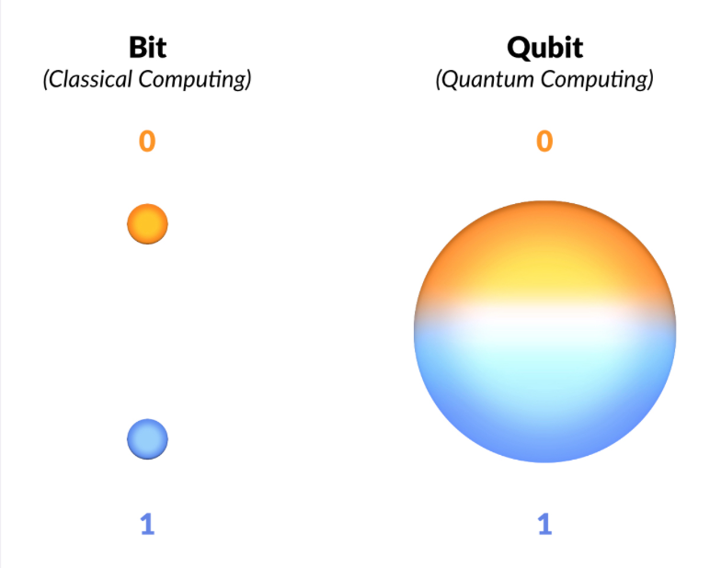

# ***Quantum Computing VS Classical Computing***

In the quantum world (physical phenomena at microscopic scales) a particle can have two or more value of an observable quantify, for example: let’s see this particle as if it were an Apple. This apple can be in two or more places at the same time, it can have none, two or more bites at the same time, it can be Green, blue, red, yellow or black at the same time etc. This phenomenon is called quantum superposition.

Events in a macroscopic environment do not seem to exhibit this type of properties of quantum physics, there is the dissonance between quantum physics and Newtonian physics, there is the difference between Quantum Computing and classical computing.

We can summarize in these four differences:

* In digital computing, a bit can only take two values: 0 or 1. In contrast, in Quantum Computing, the laws of quantum mechanics intervene, and the particle can be in coherent superposition: it can be 0, 1 and it can be 0 and 1 at a time (two orthogonal states of a subatomic particle). This allows several operations to be carried out at the same time, according to the number of Qbits.
* With conventional bits, if we had a three-bit register, there were eight possible values and the register could only take one of those values. On the other hand, if we have a vector of three Qbits, the partible can take eight different values at the same tiem thanks to the quantum superposition.
* A Quantum Computer of 30 Qbits would be equivalent to a conventional processor of 10 teraflops (millions of floating point operations per second), when computers currently work in the order of gigaflops (billions of operations).
* In classical computing the binary system is used and in Quantum Computing the unary system is used.

# ***Problems of Quantum Computing***

One of the main obstacles of Quantum Computing is the problem of quantum decoherence, which causes the loss of the unitary character (and, more specifically, the reversibility) of the steps of the quantum algorithm.

The decoherence times for the candidate systems, in particular the transverse relaxation time (in the terminology used in nuclear magnetic resonance and magnetic resonance imaging) are typically between nanoseconds and seconds, at low temperatures. The error rates are typically proportional to the ratio between operating time versus decoherence time, so that any operation must be completed in a much shorter time than the decoherence time.

If the error rate is low enough, it is possible to effectively use quantum error correction, which would allow calculations times longer than the decoherence time and, in principle, arbitrarily long.

A limit error rate of 10^4 is often cited, below which it is assumed that the efficient application of quantum error correction would be possible.

Another major problem is scalability, especially considering the considerable increase in Qbits needed for any calculation that involves error correction. For none of the currently proposed systems is a design trivial capable og handling a high enough number of Qbits to solve computationally interesting problems nowadays.

# ***Possibility of investigation***

With potential uses in the health and finance sectors, this revolution promises to open a new technological era.

As an avid fan of the Go board game, Mark Griswold was captivated by the game that was held in 2016 between the best player in the world and a computer, a milestone in the history of artificial intelligence. He still remembers the movement 102 of the first game with amazement.

The computer, developed by the subsidiary of Alphabet DeepMind, placed a white chip in a position that surprised even the experts. It was a stroke of ingenuity that human players would have had trouble planning, and a key moment in a contest that ended with the victory of the machine over man.

This technology promises exponential increases in processing capacity.

People are limited by the possibilities they can perceive and analyse, forcing them to think in a traditional, Griswold points out now.

“Humans are innovators, we think creatively, but we cannot do it at the same rhythm as a computer”

Professor of radiology in Cleveland (Ohio), Griswold has just had his own meeting with a computer that thinks creatively. The machine in question is programmed to simulate the behaviour of a Quantum Computer, a technology that could revolutionize computing.

Humans use a mixture of experience and intuition when deadling with a problem whose complete analysis is too complex, he says. In your case, that means adjusting the configuration of a magnetic resonance machine to get the best possible analysis in a specific situation, something that compares to extracting the best sound to a music instrument.

However, after only a few weeks of experimenting with quantum technology, Griswold explains that the computer has already achieved results that surpass those of its own experience.

It is, he says, the beginning of a new era, in which Quantum Computers will challenge much of what we think about the world: “We will constantly see things that challenge our intuition. It is so overherming that we cannot understand it, we do not know how much potential exists”.

“Quantum Computing could even help design new materials”, explains Griswold.

Quantum Computers, which Access quantum mechanics, a branch of physics that deals with the behaviour of subatomic particles, are an old dream of the world of technology. By taking advantage of properties that go beyond the limits of Isaac Newton’s classical physics, they promise exponential increases in processing capacity.

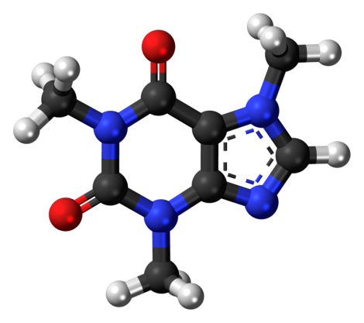

After decades in laboratories, technology is beginning to make the transition from scientific experiments to rudimentary prototypes that affect fields as diverse as chemistry and banking, and which give rise to studies already being carried out in companies ranging from Samsung to Daimler-Benz and JPMorgan Chase.

# ***Deadlines***

“It must take 30 years for this basic study to be viable –in the case of Quantum Computing, that time has already passed“says Mladen Vouk, professor of Computer Science at North Carolina State University. The result is that researchers like this university have the first opportunity to test the technology

Quantum computers will challenge much of what we think we know about the world.

JPMorgan Chase began allocating part of its research budget to Quantum Computing two years ago. To the question of whether being one of the first would bring clear advantages over rivals, Bob Stolte, managing director at the corporate and investment bank of the entity, says: “I think there could be, potentially.” But he warns:” It is too early to affirm it”.

The results could surpass even today’s most powerful artificial intelligence systems. Referring to specialized chips, or graphics processing units (GPUs), used in most of today’s most advanced machine learning systems, Stolte explains: “If you were not limited to the number of GPUs that can be achieved in a data-center, what problems could be solved, and what products could be offered to customers?” Researchers trying to take advantage of the new hardware focus on three main types of problems for which quantum machines are expected to be especially well prepared.

The first involves analysing the natural world, using computers to model the behaviour of molecules with a precision that could never be matched by current computers. “Nature is quantum mechanics, so if you had a computer that worked with quantum principles, everything would be much more direct,” says Bob Sutor, an IBM researcher.

Compared to current computers, which have to do approximations to develop a model of the behaviour of subatomic particles, Quantum Computers could do it accurately.

# ***Practical applications***

Ilyas Khan, the CEO of Cambridge Quantum Computing, a start-up that designs applications for technology, suggests that one of the first sectors to benefit will be the chemical industry. The huge increase in processing capacity will allow discovering new materials, he predicts.

Traditional computers could never process a task of this magnitude. In the quantum field, this suddenly becomes possible. This could facilitate the design of new materials, or find better ways to manage existing processes. Microsoft, for example, anticipates that it could lead to a more efficient way of capturing nitrogen from the atmosphere for use fertilizers, a process known as nitrogen fixation, which currently consumes enormous amounts of energy.

At first glance, it might seem that technology is advancing rapidly towards these levels. After building the first basic systems from a small number of quantum bits (Qbits) few years ago, companies like IBM, Rigetti and Google are moving quickly towards computers that comprise dozens of Qbits.

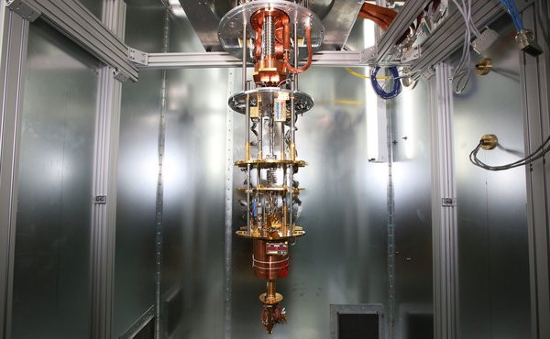

However, the numbers do not explain all reality. The current Qbits are unstable, they only maintain their quantum status for a tiny fraction of a second, and, as increasing numbers come together, the unpredictable interactions between them lead to high error rates. Learning to extract results from these “noisy” systems is already an immense challenge, and extending it to 100-qbit computers is beyond current capabilities.

# ***Applications in the real world***

Chemical companies have been among the first to start experimenting with technology. One of them is JSR Corporation, the Japanese materials multinational that has acquired a 5.5% stake in Cambridge Quantum Computing, and which is also one of the first companies to collaborate with IBM. Pharmaceutical companies, which could obtain similar benefits from long-term quantum technology, continue to remain on the side-lines. “They try to figure out when there will be enough Qbits to manage the molecules they work with”, explains Bob Sutor, an IBM researcher, as they are much larger and more complex. It is also expected that Quantum Computing will provide benefits to machine learning. Instead of simply adding more processing capacity to accelerate the programming of current machine learning systems, the technology is ready to address specific problems that pose a challenge for traditional computers. Another area of work is the optimization of complex problems that present too many variables for current computers. The new systems should address any difficult mathematical problem that has the potential to be translated into a format that specialized quantum algorithms can handle, says Sutor.

# ***Lastest news 2019***

As we have already seen, Quantum Computing is one of the ingredients of the future of information technology, so that several major technologies have their progress as one of their medium and long-term objectives. For example, Microsoft, which in order to give impetus to this technology, has launched a network called Microsoft Quantum Network.

This network is a coalition of partners that share the same vision and objective: “share knowledge and collaborate with the greatest innovators in quantum in order to help the progress of Quantum Computing. Its final objective is to help the development of the first quantum and scalable computer, as well as that of quantum applications.

In the words of the company, it is a “global community of individuals and organizations that works with Microsoft to learn, research and launch Quantum Computing hardware and applications with access to the Quantum Development Kit, relevant research and experts. “The members of the network will also have exclusive access to Azure services, as well as workshops on quantum programming and algorithm development.

To kick-start this network, Microsoft has held the Startup Summit, in which the coalition has been formalized. During this summit, Redmond announced two new additions to its network of collaborators in quantum computing, which are already part entities and companies such as 1Qbit, Borh Technology, Cambridge Quantum Computing, Entropica Labs, GTN, OTI Lumionics, ProteinQure, QC Ware, Qulab, QxBrach, Riverlane Research, Solid State AI, Strangeworks and Zapata Computing. It’s about HQS Quantum Simulations and Rahko.

The first of them is responsible for developing quantum algorithms for the predictions of molecular properties for the chemical and pharmaceutical industries. Meanwhile, the second quantum machine learning company that develops quantum and scalable chemical solutions for, among other purposes, Quantum Computers.

At this summit, the Vice President of the Azure Hardware Systems Group, Todd Holmdahl, stressed that “the Microsoft Quantum Network shows our commitment to establish the necessary agreements to develop the quantum workface and economy. We believe that both are vital for the resolution of some the most complicated problems in the world.”

While Microsoft is moving forward with its network, IBM also continues to reap breakthroughs in Quantum Computing. The company presented its first commercial Quantum Computer a few weeks ago, and has confirmed that it has achieved the best performance achieved to date with a Quantum Computer. In addition, according to Computer Business Review, this milestone is accompanied by the lower error rates that have been measured so far in the world of quantum computing.

The achieved performance, which has double every year since 2017, has been measured with the Quantum Volume index, a metric system that collect the Qbits that a Quantum Computer has, as well as measurement and threshold errors. Also communication between devices and connectivity, as well as the efficiency of the circuit software compiler.

This has been confirmed by the IBM Q research team, which has detailed that a quantum volume of 16 has already been achieved. Until now, the maximum that the research team in charge of working on the advancement of Quantum computing at IBM was 8. Despite the progress recorded, Quantum Computers continue to produce too much “noise” to get calculations with some importance and weight. The results were presented at the meeting of the American Society of Physics (APS).

# ***Conclusion***

In conclusion, Quantum Computers are based on the use of Qbits instead of bits, and gives rise to new “logical gates” that make possible new algorithms.

They have a calculation capacity much higher than the current computers thanks to the massive (exponential) parallelism due to the superposition of states in the Qbit.

One aspect to note is that in the field of cryptography they propose a new approach: absolute security control at the communication level and their capacity to perform factorization operations (decomposition into prime numbers), which represents a threat to the encrypted communications they use many institutions in their security systems, and that are based in turn on the difficulty of making codes.

Finally, to say that Quantum Computing is a field in which there is still much to discover.

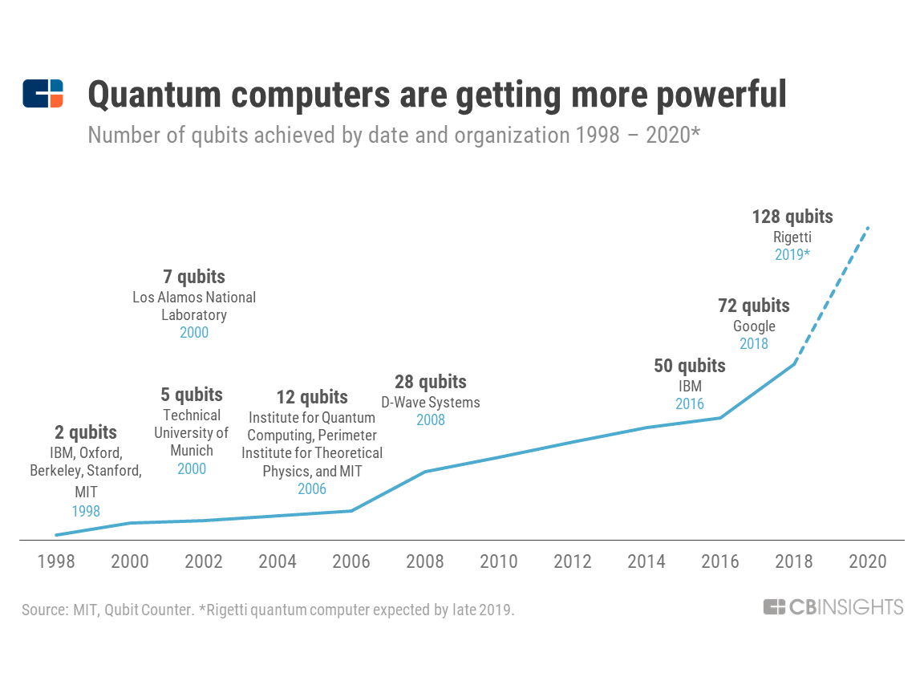

# ***Bibliography (web-links)***

<https://hackernoon.com/a-brief-introduction-to-quantum-computing-d21e578cb7ed>

<http://mmrc.amss.cas.cn/tlb/201702/W020170224608149125645.pdf>

<https://www.explainthatstuff.com/quantum-computing.html>

<https://www.youtube.com/watch?v=QuR969uMICM>

<https://www.research.ibm.com/ibm-q/learn/what-is-quantum-computing/>

<https://www.dwavesys.com/quantum-computing>

<http://www.thphys.nuim.ie/staff/joost/TQM/QvC.html>

<https://singularityhub.com/2019/04/05/quantum-computers-could-go-mainstream-sooner-than-we-think/#sm.000yr3jil19j6dv9y7y2adg5huctv>

<https://www2.deloitte.com/content/dam/Deloitte/pe/Documents/audit/De%20fantas%C3%ADa%20a%20realidad%20(Abril%202017).pdf>

<http://www.practia.global/Perspectiva-Digital/Paginas/la-computadora-cu%C3%A1ntica-y-sus-implicancias-a-problemas-de-seguridad.aspx>

<https://www.youtube.com/watch?v=PD2rdGRki6I>

<https://www.youtube.com/watch?v=035rUtCPKWU>

<https://www.youtube.com/watch?v=YpYuBEzfRlM>

<https://www.elfinanciero.com.mx/tech/que-es-y-para-que-sirve-una-computadora-cuantica>

<http://www.uchile.cl/noticias/130443/la-computacion-cuantica-y-sus-posibilidades-para-la-fisica>

<https://www.infobae.com/america/tecno/2018/07/29/las-promesas-de-la-computacion-cuantica-y-un-nuevo-record-mundial-en-simulacion/>

<https://news.harvard.edu/gazette/tag/quantum-computing/>

<https://www.elobservador.com.uy/nota/promesas-y-hechos-de-la-computacion-cuantica-2018120500>

<https://www.bbc.com/mundo/noticias/2016/05/160505_tecnologia_computadora_cuantica_ibm_yv>